SHA Recorded Presentation Submission Instructions

Submit a video recording of your slide presentation narrated with your audio
- Deadline: December 15, 2023.
- Technical Requirements: Submit a video recording of your slide presentation as an MP4 file. (Other allowable file formats are: .avi, .mkv, .webm, and .mov)
- How to record your video:
- Record your presentation on your computer.
- Use a web conferencing platform to record your presentation.
- Use a media or audio-visual department at your institution (if available).

TECHNICAL SUGGESTIONS
Getting Started:
- Create your presentation content slides as you would normally in PowerPoint or Keynote.
- Open slides in full screen mode. For example, if using Microsoft PowerPoint, give your presentation in “Slide Show” mode.

Audio tips:
- Use a microphone and test audio before recording. A wired headset will generally produce the best quality audio and pick up less ambient noise.
- Record presentation from a quiet location.
- Begin your presentation on your content slides. A brief pause in between slide transitions may be needed with some recording applications.

Recording suggestions:
- PowerPoint or Keynote – use PowerPoint or Keynote to record your presentation and export a MP4 file**
- PowerPoint (Windows, Mac): or see instructions screenshots on following pages
- PowerPoint Instruction Link: https://support.microsoft.com/en-us/office/record-a-slide-show-with-narration-and-slide-timings-0b9502c6-5f6c-40ae-b1e7-e47d8741161c
- PowerPoint How to Video Link: https://www.youtube.com/watch?v=D8JV3w4TOVw&feature=youtu.be
- Keynote (Mac only):
- Instruction Link: https://support.apple.com/guide/keynote/record-audio-tan8a5df9cc5/mac
- Keynote How to Video Link: https://www.youtube.com/watch?v=fe280TjbAXw
- Record your own - free tool
- Loom (Chrome Browser on Windows, Mac): https://support.loom.com/hc/en-us/articles/360002236078-How-to-record-a-presentation-with-Loom-
- Record your own - webinar services
      - Zoom (Windows, Mac): https://support.zoom.us/hc/en-us/articles/201362473-Local-Recording
      - GoToMeeting - $19/month (Windows, Mac): https://www.gotomeeting.com/features/online-meeting-recording
      - Amazon Chime (Windows, Mac): https://answers.chime.aws/articles/132/recording-a-chime-meeting.html

**PLEASE NOTE: Files recorded using Prezi software should not be used.

Save and Review:
- Make sure your presentation video is saved as an MP4 file. (Other allowable file formats are: .avi, .mkv, .webm, and .mov)
- Playback and review your presentation video prior to submitting.

Record Narration for PowerPoint

Step-by-step instructions for how to record your narration and add it to your PowerPoint slides:

Step 1. Setup Your Microphone
Before you start to record audio inside PowerPoint, start off by making sure that your microphone is plugged in and ready to record. Whether you're on Windows or macOS, you'll want to access the audio device settings and set your default microphone.
You can't change which device to record from or set volume levels for the microphone inside of PowerPoint, so make sure that it's ready for recording before you dive into PowerPoint.

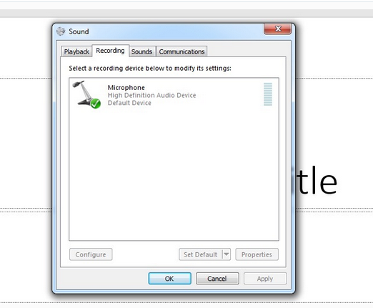
You can't change the microphone settings inside of PowerPoint, so make sure you use the Windows or macOS settings to choose your mic and set levels before you start recording in PowerPoint.

Step 2. Press Record in PowerPoint
To record narrations in PowerPoint, start off by finding the Slide Show tab on PowerPoint's ribbon. Click on the Slide Show tab to change the available options.

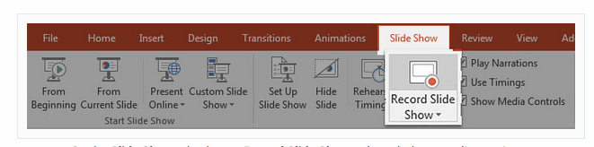
On the Slide Show tab, choose Record Slide Show to launch the recording options.

Make sure that you start on the first slide in PowerPoint to record audio and timings for the entire presentation.
Now, find the Record Slide Show button and click on it. A new window will pop up with two options to set before you start recording:
- Slide and animation timings. Leave this option checked if you want to setup the timings for your slides. Basically, this option allows you to sync up your narration with slides. I recommend leaving it on.
- Narrations, ink, and laser pointer. Definitely leave this option checked to record audio narrations, even if you don't plant to use ink or the pointer to add illustrations.

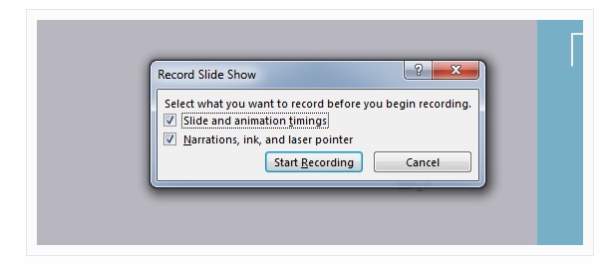
Leave both of these options checked to record audio narrations and synchronize slide change timings.

Make sure you're ready before you press Start Recording. As soon as you click on it, PowerPoint will begin to record your screen and audio.

Step 3. Start Recording Your Narration
Once you Start Recording, PowerPoint will go into a full screen presentation view. It also begins recording audio from your microphone.

In the upper left corner of the window, you'll see a Recording window with a runtime counter and other buttons. Use this to keep track of the length of your presentation.

You can use the arrow keys on your keyboard to switch between slides while recording. Use the right arrow to jump to the next slide, or the left arrow to move to the previous PowerPoint slide.
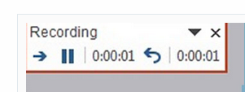

Basically, PowerPoint is recording exactly what's on your screen along with the audio you speak into your microphone. When you're finished, click on the X button in the upper right corner of the Recording window to complete the audio recording.

Step 4. Use Annotations (Optional)
While you're recording your presentation, you can also add annotations to your PowerPoint. You can use a digital pen, highlighter or laser pointer to add markings.

This feature is great when wanting to gesture toward something specific on the slide during your narration.

To use annotations, hover in the lower left corner of your presentation while recording the presentation. There are extra tools that you can choose from. For an annotation, click on the third icon of the left to choose from one of the tools.
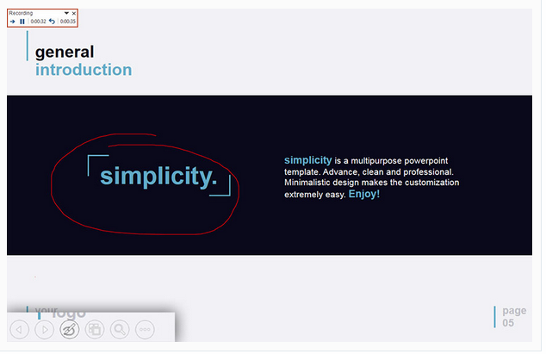

After you select a tool, you can draw on the slide to add the annotation. It doesn't change the original slide, but it does add it to the recorded version of your presentation. Viewers will see these annotations drawn in while watching the recorded version of your presentation.

Step 5. Reset Presentation Timings as Needed
Let's say that you had the perfect audio take, but the timings of your slide changes were off by a bit. That's no problem; we can readily restart the process of setting your slide timings.

To do that, make sure that you're on the Slide Show tab and click on Rehearse Timings. Your presentation will go into full screen mode and you can use the arrow keys to changes slides to set new timings.

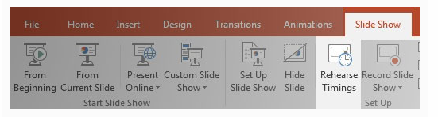

Choose Rehearse Timings to re-do the timing of your slide changes as needed.

Now that you're finished, you can send your presentation onto a viewer with your narration embedded. When they play the presentation, your record narration will play with it, on the timings you've setup while rehearsing.

