Instructions for Poster Presenters

ALL POSTERS WILL BE PRESENTED IN THE ACADIA ROOM.

Schedule: Each poster session will be scheduled for 4 hours (morning and afternoon) on Thursday, Friday, and Saturday (January 4–6). For morning sessions, posters must be mounted in their assigned space by 8:00 am and promptly removed by 12:00 pm. For afternoon sessions, posters must be mounted in their assigned space by 1:00 pm and promptly removed by 5:00 pm.

Space: You will be assigned one side of a poster board (8 feet by 4 feet) to display your poster which must be contained entirely within this space. Push pins to mount your poster and any associated materials will be provided at the conference. Extra push pins may be requested at the Registration Desk, if necessary. Please note that no tables, chairs, or access to electrical outlets will be provided. Once your session has finished, please remove your poster and all other associated materials (handouts, business cards, etc.) but leave the push pins on the poster board for the next presenter.

Presentation: You must be stationed at your poster for a minimum of 1 hour during your assigned session. Presenters will be provided with a sign to mount next to the poster indicating when you will be present and available for questions (see example below).

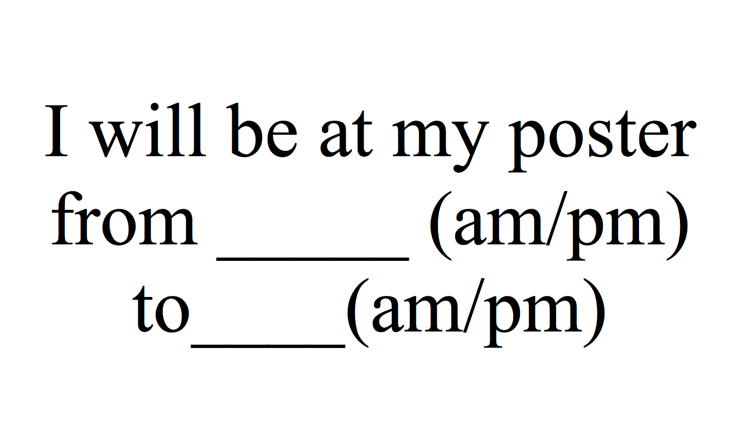

Presenters are encouraged to mount business cards next to your poster in the event that a viewer has questions in your absence and would like to contact you at a later time. An example of using push pins to mount business cards is pictured below.
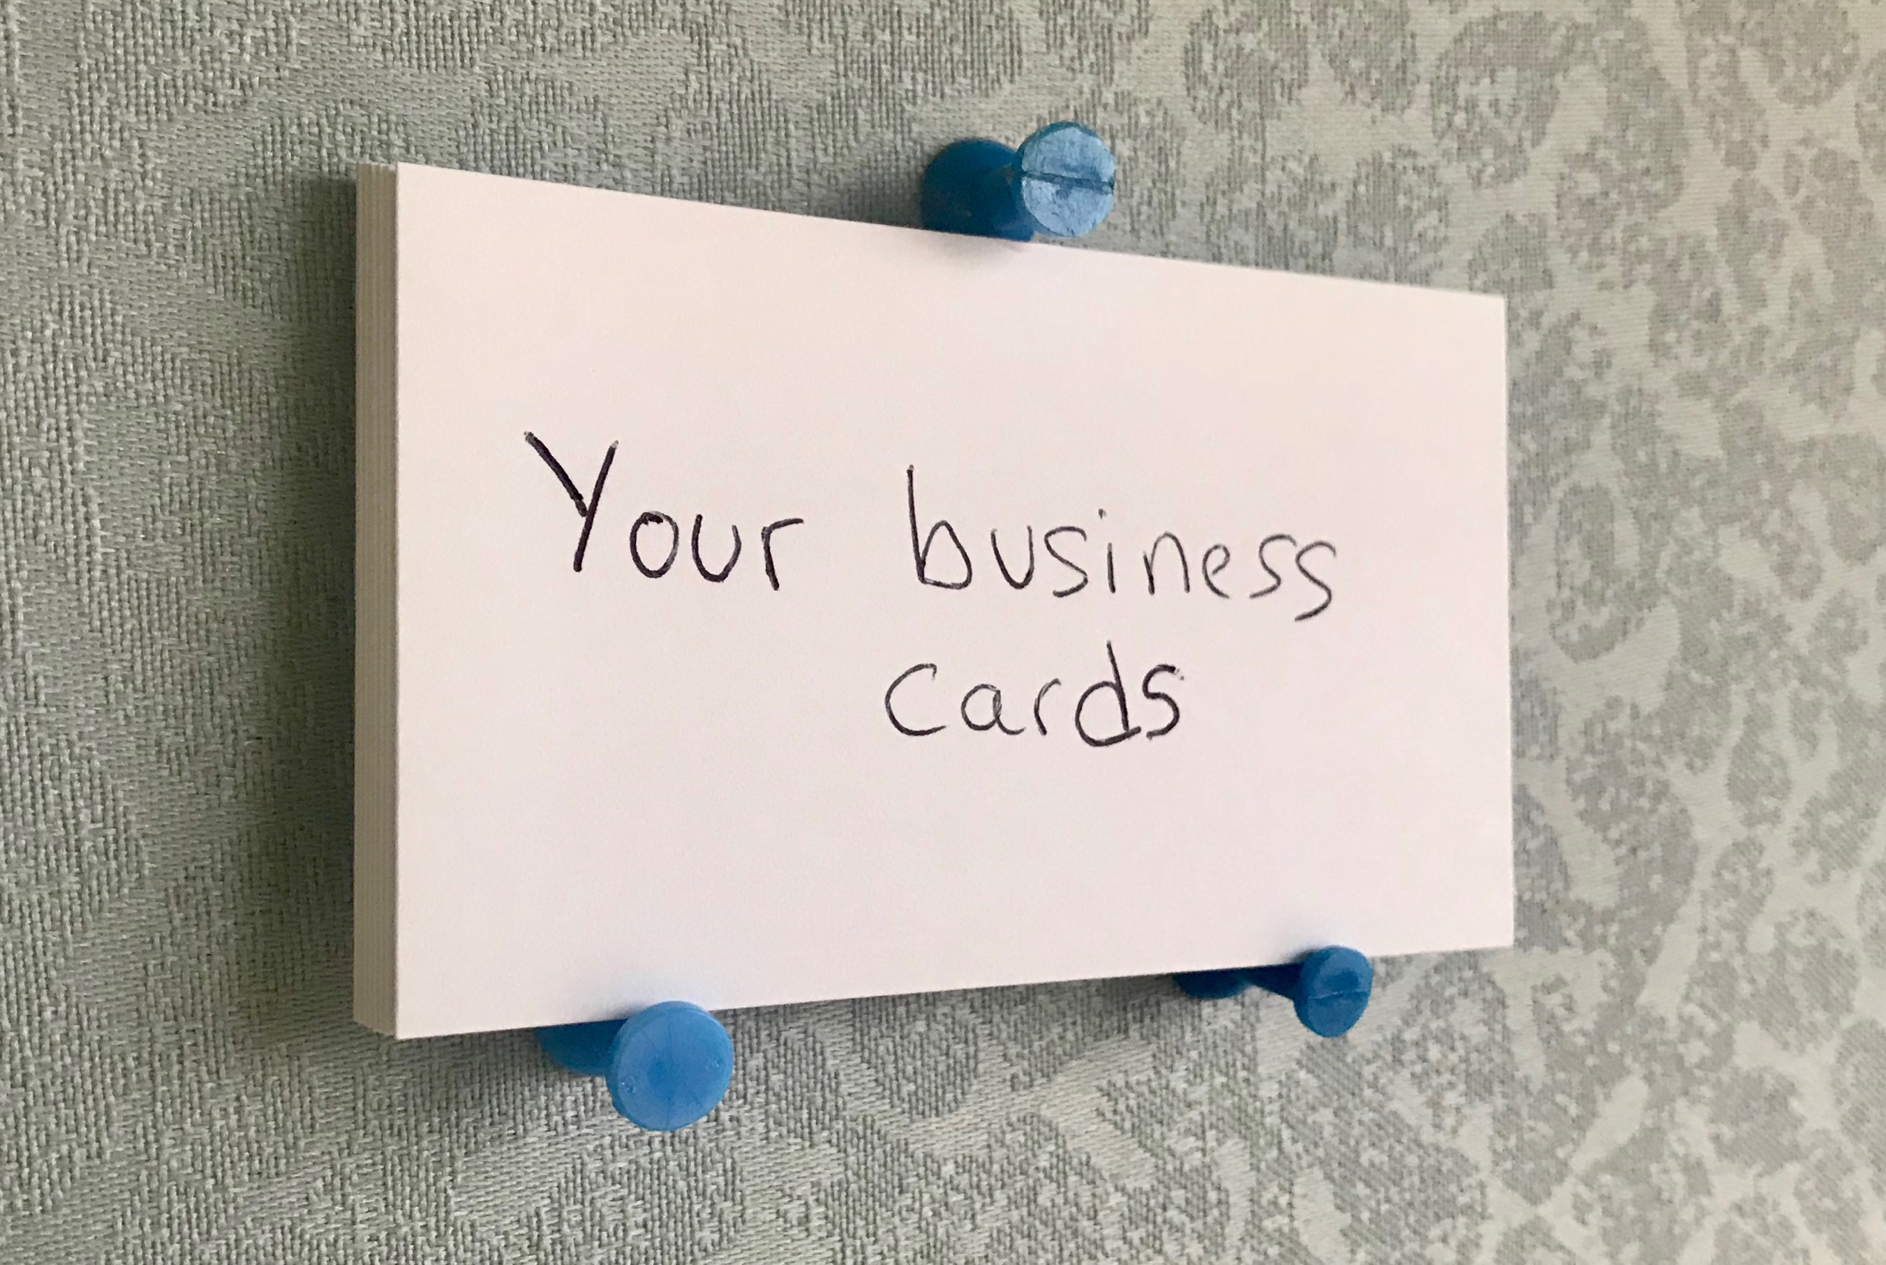

Recommendations: A poster is a summary of research that should be presented in a visually engaging way. To really make your poster stand out:

- Use fonts that are easy to read and of sizes large enough to be read from 4 feet away (e.g., title = 72 pt., headings = 30–60 pt., text = 18–24 pt. font);

- Include name, title, and affiliation of the presenter(s) in addition to the poster title;

- Rely more on illustrations, graphs, photos, maps, etc. than text. Any text included should be clear, concise, and to the point;

- Use bulleted lists instead of paragraphs where possible;

- Design the layout in such a way to avoid a cluttered appearance;

- If appropriate, use arrows to indicate the flow of information from introduction to conclusion;

- Consider printing 8.5-inch by 11-inch versions of your poster to serve as a handout.

