2017 Society for Historical Archaeology
Student Paper Competition Guidelines

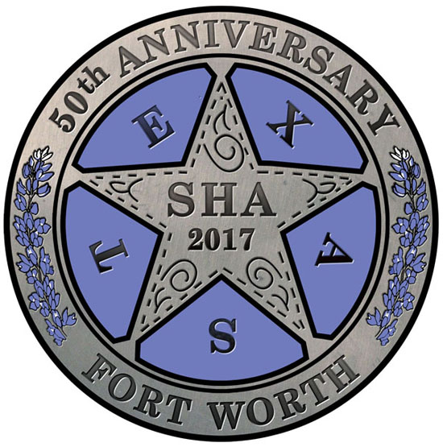
The 16th Society for Historical Archaeology Student Paper Prize will be awarded at the 50th Conference on Historical and Underwater Archaeology, to be held January 4-7, 2017 in Fort Worth, Texas. The prize will be awarded to a student, or students, whose written version of a conference paper is judged superior in the areas of originality, research merit, clarity of presentation, professionalism, and of potential relevance to a considerable segment of the archaeological community. One prize will be awarded. The winning author(s) will receive a book prize consisting of titles donated by the many presses and organizations exhibiting in the SHA Conference Book Room (totaling almost $1,600 worth of items in 2016) and a letter of recognition from the SHA President. The winning author(s) will be encouraged to submit his or her paper to be reviewed for possible publication in Historical Archaeology. The results of the competition will be communicated to the entrants prior to the meeting and the winner will be announced at the annual business meeting.

Criteria
1) Entrants must be student members of the SHA prior to submission of papers and registered for the 2017 annual meeting by December 2015.

2) The paper must be prepared according to current Historical Archaeology guidelines (see the SHA website for these details) and be submitted by November 11, 2016. Submissions must be made electronically (MS Word or PDF) to Carolyn White, chair of the Student Paper Prize Subcommittee at clwhite@unr.edu. If you have a problem with an electronic submission, please contact Carolyn White at the email address above.

3) The paper must be presented by one of the student authors at the annual meeting.

4) There may be a maximum of three authors on the paper. All of the authors must be students and members of SHA. In the event of a winning co‐authored paper, the authors will split the available book prizes.

5) Papers are to be limited to no more than 10 pages of double-spaced text using standard fonts and margins. The intent is that the length of the paper submitted must be in line with what can reasonably be presented in 15 minutes. Papers that are deemed by the committee to be impossible to deliver in a standard 15 minute format will be eliminated from the competition.

6) Any additional questions may be addressed to Carolyn White via email (clwhite@unr.edu).

