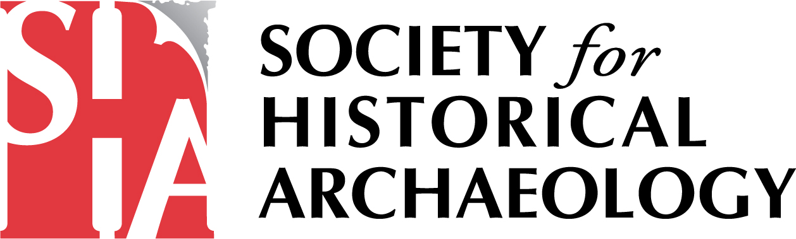

Advertising with the Society for Historical Archaeology

The SHA is the world's leading scholarly society devoted to the archaeology and material culture of the modern world. Membership is roughly 2,000, and thousands more have access to our journal through our publishing partner, Springer.. Members come from more than forty countries, and most are professional archaeologists who teach, work in museums, consulting firms or have government posts. Through our close relationship with the Advisory Council for Underwater Archaeology, our members also include many of the world’s underwater archaeologists.

SHA Newsletter

Please Note: The Newsletter will accept a broad range of advertisements relevant to archaeology including, publishers, academic programs in Anthropology, Archaeology, etc., national and regional archaeology groups, suppliers, consultants, and vendors. The SHA reserves the right to accept or decline advertising at its own discretion. Advertisers must adhere to the ethical principles of the Society.

 | One Issue | Two or More Issues  (arranged in advance)
Quarter Page  (3 3/4" x 4 7/8”) | $100 | $90 each issue
Half Page  (7 1/2” x 4 7/8”) | $180 | $150 each issue
Full Page  (7 1/2” x 9 3/4”) | $300 | $225 each issue

The Newsletter is printed quarterly and received by all individual members, roughly 2,000.

To advertise, or for more information, contact us at: hq@sha.org.

