A guide to computers at Leicester and electrical supply in the UK

Computers at Leicester
The University of Leicester runs PCs throughout the campus, which operate with Windows 7 and Office 2010. Delegates should ensure that their PowerPoint presentations are compatible, and are loaded to the lecture room computer before the start of their session.
In the event that a delegate needs to connect an Apple MacBook to data projector, they will need to bring the required adaptor with them.

Electrical supply in the UK
The electrical supply in the United Kingdom is 230v 50hz. Plugs and sockets are different to those in most other countries, involving a three-pin formation. If your appliances operate on a different current (such as those from North America) you will need a power converter and plug adapter.
Many appliances (e.g. phone chargers, laptop computers) support dual voltage and dual frequency. If this is the case, a plate/tag will be located on the item stating "120/240v, 50/60Hz". In this case, you will only need a plug adaptor.
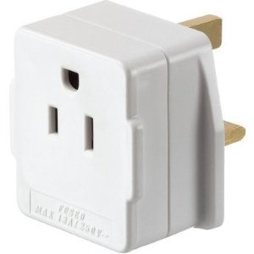 | A US – UK plug adaptor

Power converters step down the voltage from 240v to 120v, allowing equipment which is not dual voltage to operate at the voltage for which it was designed. Plug adaptors and converters can be purchased at airport shops, travel stores, and electronics stores.

