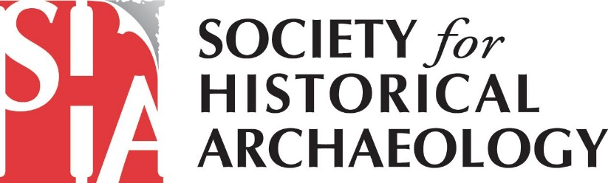
SHA Government Affairs Newsletter – January 2020
This is the inaugural Newsletter of the SHA’s Government Affairs Committee. The purpose of the Newsletter is to keep SHA members informed about issues that affect national and international historical archaeological heritage. We plan to send out a Newsletter every month or two months depending on what is happening in Washington, D.C., across the country, and around the world.
Together with leading historic preservation groups from across the nation, SHA is committed to building a grassroots movement of scholars, professionals, and volunteers who value preservation. As a founding member of the Coalition for American Heritage, SHA is able to respond quickly and effectively to government actions that impact heritage efforts and historical archaeological sites.
In this first Newsletter, we will update you on recent historic preservation victories and good news. But there is also troubling news we need to tell you about.
Historic Preservation Funding in the U.S
Last month, Congress passed a bill giving preservation programs their highest-ever levels of funding, including $118.6 million for the Historic Preservation Fund, a $16 million increase over last year. This success is the culmination of all the efforts SHA and our advocacy partners have made to meet with Members of Congress, send letters, and get involved in the political process. Compared to three years ago, when SHA helped found the Coalition for American Heritage, the federal preservation budget has increased by 46%!

SHA is also pleased to announce that legislation we helped develop, the African-American Burial Grounds Network Act, has now been introduced in both the U.S. House and Senate. The bill would help identify and protect historic cemeteries. It has strong bipartisan support in both chambers. We led 100 groups in contacting Congress in support of the legislation. These groups included the United Negro College Fund, the Sierra Club, the Society for California Archaeology, the National Parks Conservation Association, the University of North Carolina system, and many others.
Looking Ahead – Upcoming Challenges
SHA is now analyzing and preparing a response to the Trump Administration’s proposed changes to the regulation implementing the National Environmental Policy Act (NEPA). We are very concerned that, if these changes are made, they will dramatically reduce consideration of cultural resources on infrastructure projects. In our initial review, the most worrisome changes are:
- Introducing a new concept – “a threshold analysis” – to see if NEPA should apply at all, particularly for privately financed projects with “minimal government funding or involvement” (terms that have yet to be defined). This has the potential of reducing the number of projects requiring cultural resources review.
- Limiting the consideration of indirect effects on the environment, effects that are often greater than direct effects. This has the potential of limiting the assessment of project effects on cultural resources.
- Banning groups that don’t weigh in during the public comment period from raising objections in litigation later in the process. This change runs counter to the fundamental NEPA goal of giving the public a voice in federal decision making and would curtail our ability to challenge potentially harmful projects.
We will also be preparing a response to the Administration’s revised water rule, which would remove environmental protections for roughly half the country’s wetlands and millions of miles of streams and arroyos, including the vast majority of waterways in western states like Arizona, Colorado, Nevada, New Mexico, and Utah. This final rule would replace the Obama-era regulation, called the Waters of the U.S. (WOTUS). Our concern is that these changes will greatly reduce consideration of cultural resources because NEPA and Section 106 of the National Historic Preservation Act would not be applied to these, now unprotected waterways.
How You Can Get Involved
For additional information on our advocacy efforts, please sign up for email alerts from the Coalition for American Heritage at https://heritagecoalition.org/for-individuals/ and follow the Coalition on Facebook at @heritagecoalition. You’ll get Calls to Action with sample scripts for emailing/calling your Member of Congress. You will also receive information on how to send a comment letter to federal agencies and examples of what you may choose to say.
Also, please consider joining SHA’s Government Affairs Committee! Given increasing threats (to both terrestrial and underwater sites) from the current Administration, your involvement is critical. If interested, please contact Terry Klein at tklein@srifoundation.org or Marion Werkheiser (marion@culturalheritagepartners.com). We look forward to working alongside you to advance the protection of our historical archaeological heritage!

