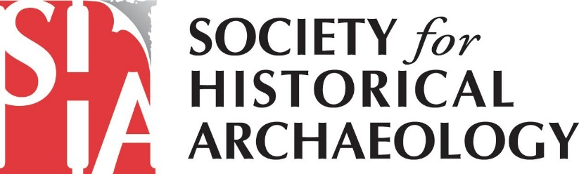
SHA Government Affairs Newsletter – September 2020
African American Burial Grounds Network Act Featured in National Geographic!
National Geographic published an interesting, comprehensive story about the preservation of African American burial grounds and HR 1179/S 2827, the African American Burial Grounds Network Act. SHA played a pivotal role in helping develop and promote this legislation. Thanks to the advocacy of SHA members, the bill has the support of 49 cosponsors in the House, 6 in the Senate, and more than 90 advocacy organizations across America. Read the National Geographic story at: https://www.nationalgeographic.com/travel/2020/08/historic-black-cemeteries-at-risk-can-they-be-preserved/
If you haven’t contacted your Members of Congress yet about this important legislation, get helpful guidance and a sample e-mail message here: https://heritagecoalition.org/call-to-action-2/.
Read the Results of the Coalition for American Heritage Candidate Survey

The Coalition for American Heritage sent a survey to every candidate for Congress across the country. As the results come in, they are posted on the Coalition’s website (https://bit.ly/2QYjbuR).

Invite Your Candidates to Answer the Survey!

Find out what your candidates think about the most critical issues in historic preservation policy! Send an email to their campaign offices and ask them to complete the survey. Your message could say:

As a member of the Society for Historical Archaeology, your views on historic preservation are important to me. Would you please take the time to answer a short survey on preservation from the Coalition for American Heritage? Your answers will be posted on the Coalition website and shared on social media. The survey is available at: https://www.surveymonkey.com/r/X6KVFYZ

Coronavirus Relief Legislation Deadlocked

Congress remains in a stalemate over passage of an additional COVID-19 relief bill. In May, the Democratic majority in the U.S. House of Representatives passed a bill, called the HEROES Act, with more than $3 trillion in funding for state and local governments, direct payments, and testing and contact tracing. The Republican majority in the Senate, however, has refused to consider the bill.

Senate leaders proposed a $1 trillion bill, but it failed to pass. Speakers Pelosi and Senate Minority Leader both opposed the legislation, which they said fails to provide sufficient help to American suffering the repercussions of the pandemic.

23 States File Suit Against the U.S. Government re: Changes to the National Environmental Policy Act (NEPA) Regulations

The Attorney Generals of California and Washington are leading a group of 23 states in a
lawsuit challenging the Trump Administration’s changes to the NEPA regulations. Additional information on the lawsuit is available in this article in the New York Times.
National Park Service (NPS) Director Retired
NPS Acting Director David Vela abruptly chose to retire in late August. His decision was seen as linked to the FOX News interview he gave earlier that week. Margaret Everson, Counselor to Secretary Bernhardt supporting the NPS and U.S. Fish and Wildlife Service, is replacing him.

Legislative Update
The Badger-Two Medicine Protection Act was introduced. It would permanently protect 130,000 acres of the Badger-Two Medicine as a “cultural heritage area,” a first-of-its-kind designation that could potentially usher in a new national system for protecting public lands in Indian Country.

Forest Service Draft Rules Open for Comment

On August 31st, the U.S. Forest Service published draft revised rules on oil and gas development on national forests. The agency will accept public comment until November 2nd. SHA is considering whether to comment. To read the draft rule, go to: https://www.federalregister.gov/documents/2020/09/01/2020-18518/oil-and-gas-resources

Voting Will be Different This Year – Are You Ready?
Because of the ongoing pandemic, many states are offering greater flexibility in how you can cast your vote in the November 3rd election. This year, you may want to vote early or use a mail-in ballot. Make a plan to vote! Log in to www.vote.org, a non-partisan site, for help checking your registration, requesting an absentee ballot, or finding your polling place.
How You Can Get Involved
For additional information on SHA’s advocacy efforts, please sign up for email alerts from the Coalition for American Heritage at https://heritagecoalition.org/for-individuals/ and follow the Coalition on Facebook at @heritagecoalition and on LinkedIn at https://www.linkedin.com/company/coalition-for-american-heritage/. You’ll get Calls to Action with sample scripts for emailing/calling your Member of Congress. You will also receive information on how to send a comment letter to federal agencies and examples of what you may choose to say.
Also, please consider joining SHA’s Government Affairs Committee! Given increasing threats (to both terrestrial and underwater sites) from the current Administration, your involvement is critical. If interested, please contact Terry Klein at tklein@srifoundation.org or Marion Werkheiser (marion@culturalheritagepartners.com). We look forward to working alongside you to advance the protection of our historical archaeological heritage!

