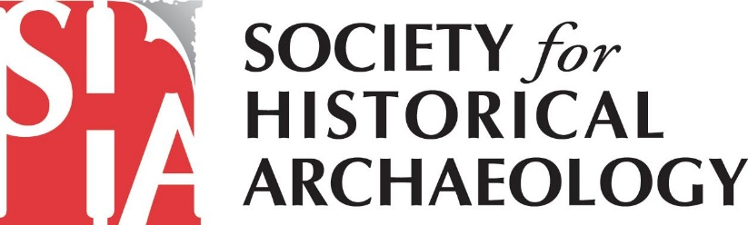
SHA Government Affairs Newsletter – November 2020

SHA Meeting with OIRA Over Changes to National Register Regulations

Members of the SHA leadership met with the White House Office of Information and Regulatory Affairs (OIRA) to voice our objections to the proposed changes to the National Park Service’s National Register of Historic Places regulations. Review by OIRA is the final step before the Administration finalizes the changes. Therefore, it was our last chance to highlight the ways that the new regulations could imperil historic resources.

In our letter (https://heritagecoalition.org/wp-content/uploads/2019/05/Coalition-for-American-Heritage-Comments-on-National-Park-Service-National-Register-Proposed-Rule-RIN-1024-AE49-final.pdf) to the National Park Service, SHA and the Coalition for American Heritage expressed serious concerns about proposed rule that would give federal agencies the power to block National Register listings and eligibility determinations of federally owned properties. An individual or company that owns the majority of the land within a historic district would have the ability to block the National Register-listing of the historic district, even though the majority of the other properties owners in the district agree to the listing. These changes appear designed to allow mining and energy developers to block National Register listings that encompass large-scale landscapes defined as historic districts, such as those in Alaska and the western United States that are culturally significant to Native Americans.

SHA Supports National Heritage Area Designation for Bronzeville Neighborhood
SHA, the Coalition for American Heritage, and several other preservation organizations asked committees in the U.S. House and Senate to consider a bill to create a national heritage area in the Bronzeville neighborhood of Chicago, Illinois. If enacted into law, the national heritage area would protect and highlight a vital aspect of African American history as well as a Civil War-era fort where archaeological research is ongoing.
For additional details on this legislation, read the letter here (https://heritagecoalition.org/wp-content/uploads/2020/10/Senate-Letter-Bronzeville-Black-Metropolis.pdf).

Federal Funding for Preservation Programs

Funding for federal government operations will lapse on Dec. 11th unless Congress and the Administration reach an agreement. At present, the House and Senate are negotiating their differences on appropriations for the Department of the Interior. For a close look at federal funding for preservation programs, read the Coalition for American Heritage’s analysis:
https://heritagecoalition.org/federal-preservation-funding-key-updates/?fbclid=IwAR21ykSjGI7W4iIhuuEh27HRLq336QBrxDQ-lt07_u1l1ufHopgTN_IrCfs

Judge Says BLM Director William Perry Pendley Serving Unlawfully

Montana Governor Steve Bullock filed a lawsuit against the Trump Administration saying that William Perry Pendley, the top official at the Bureau of Land Management, was serving unlawfully because his temporary appointment exceeded the 210-day limit. The judge indicated that he could toss out policies overseen by Pendley during his tenure. On October 16th, the judge invalidated three BLM land-use plans in Montana.

The repercussions of this decision could be far-reaching for BLM and other agencies. Officials leading BLM, the National Park Service, and the Office of Surface Mining Reclamation and Enforcement have also been in their positions as temporary appointees and are not Senate confirmed. It’s possible that their decisions will also be successfully challenged on the same grounds.

Groups Suing Federal Government for Use of Tear Gas Aimed at BLM Protestors

The American Civil Liberties Union of Oregon and four environmental groups filed a lawsuit alleging that the federal government violated the National Environmental Policy Act when it deployed tear gas against Black Lives Matter protestors without first assessing the potential environmental impacts.

How You Can Get Involved
For additional information on SHA’s advocacy efforts, please sign up for email alerts from the Coalition for American Heritage at https://heritagecoalition.org/for-individuals/ and follow the Coalition on Facebook at @heritagecoalition and on LinkedIn at https://www.linkedin.com/company/coalition-for-american-heritage/. You’ll get Calls to Action with sample scripts for emailing/calling your Member of Congress. You will also receive information on how to send a comment letter to federal agencies and examples of what you may choose to say.
Also, please consider joining SHA’s Government Affairs Committee! Given increasing threats (to both terrestrial and underwater sites) from the current Administration, your involvement is critical. If interested, please contact Terry Klein at tklein@srifoundation.org or Marion Werkheiser (marion@culturalheritagepartners.com). We look forward to working alongside you to advance the protection of our historical archaeological heritage!

