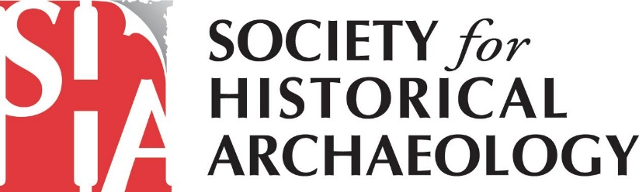
SHA Government Affairs Newsletter – May 2020
Responding to the Economic Fallout from COVID-19
Given the ongoing economic devastation caused by the pandemic, Congress is continue looking for ways to provide assistance to the public.
Speaker Nancy Pelosi proposed a $3-trillion-dollar package that would provide direct payments to families, aid state, local and tribal governments, and fund additional testing. Republican leaders have not yet released their plan for another bill, and Senator McConnell is saying that he doesn’t want to vote on anything before June.
As both parties negotiate the next pandemic-relief bill, SHA will continue advocating for funds to aid priorities for the preservation and protection of our nation’s historical archaeological heritage and to serve the communities linked to this heritage.
SHA Urges Congress to Invest in Preservation
SHA and the Coalition for American Heritage urged top Congressional leaders to use investments in historic preservation to maintain important government services and spur economic growth. The Coalition asked that the legislation:
- avoid creating any legislation that exempts infrastructure projects from historic preservation reviews designed to identify and preserve cultural resources and historic properties;
- provide $120 million for State and Tribal Historic Preservation Offices to enable their work while social distancing/teleworking policies are in place, and while they support local economic recovery;
- allocate $300 million to existing competitive grant programs in the Historic Preservation Fund (HPF);
- incorporate the recommendations of the Historic Tax Credit Growth and Opportunity Act (S. 2615/HR. 2825); and
- provide additional funding for the national endowments and the Institute of Museum and Library Services.

Incorporating these recommendations into the bill would aid America’s economic recovery by providing targeted funding for existing programs with a proven record of creating jobs and growing local economies. To read a full copy of the letter, click here. (https://bit.ly/36yermZ)

Help Preserve Underwater Tribal Heritage
Just under the waters off the central coast of California, are the submerged, ancestral lands and villages of the Chumash nation. A national marine sanctuary has been nominated for this area. However, the nomination may lapse without strong public support. It is subject to a five-year review, intended to ensure that all active nominations remain relevant to the surrounding community and the country as a whole.
To advocate for the e significance of the proposed Chumash Heritage National Marine Sanctuary, submit a letter (https://bit.ly/2XDUM0E) supporting the nomination. The deadline is June 15th. You may also choose to participate in a public meeting (https://nominate.noaa.gov/5-year-review.html#chumash) on May 27th.
Learn more about the site in the 2015 Chumash Heritage National Marine Sanctuary Nomination (https://bit.ly/2ZFn2CG).

What Will the 2020 Election Mean for Preservation?
You’re invited to join a free webinar (https://bit.ly/36ijqIe), “Election 2020: What’s at Stake for Historic Preservation” on June 17th at 2:00 p.m. ET.
- Find out how the President’s political appointees could re-shape preservation policy at various federal agencies.
- Learn how the balance of power in Congress could help or hamstring the next President.
- Hear how a little-known law, called the Congressional Review Act, could enable a new president to reverse regulatory changes made by the previous administration.

Register now (https://bit.ly/36ijqIe) to participate! Hear our recommendations on the best ways to ensure the protection of America's cultural resources, including:
- Improving tribal consultation policies,
- Protecting public lands,
- Valuing the advice of scientists and other experts,
- Promoting creative mitigation efforts to address adverse impacts to heritage resources, and
- Halting international trafficking in objects of cultural patrimony.
A recorded version will also be available afterward.
How You Can Get Involved
For additional information on SHA’s advocacy efforts, please sign up for email alerts from the Coalition for American Heritage at https://heritagecoalition.org/for-individuals/ and follow the Coalition on Facebook at @heritagecoalition and on LinkedIn at https://www.linkedin.com/company/coalition-for-american-heritage/. You’ll get Calls to Action with sample scripts for emailing/calling your Member of Congress. You will also receive information on how to send a comment letter to federal agencies and examples of what you may choose to say.
Also, please consider joining SHA’s Government Affairs Committee! Given increasing threats (to both terrestrial and underwater sites) from the current Administration, your involvement is critical. If interested, please contact Terry Klein at tklein@srifoundation.org or Marion Werkheiser (marion@culturalheritagepartners.com). We look forward to working alongside you to advance the protection of our historical archaeological heritage!

