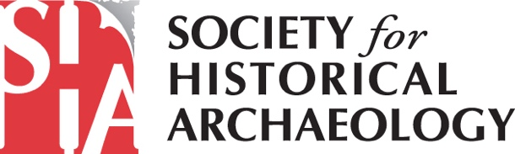

2026 Conference on Historical and Underwater Archaeology

January 7-10, 2026 – Detroit, Michigan

Final Conference Program Book

Advertising Contract
■ Email completed form with payment sara@sha.org.
with payment information to:

 Or mail payment/form to: Society for Historical Archaeology
72 North State Road
Briarcliff Manor, NY 10510

 Questions? Call: Sara Mascia – 914-588-3720
Email: sara@sha.org.

Name__________________________________________________________________

Organization____________________________________________________________

Address________________________________________________________________

City_______________State________Postal Code__________ Country_____________

Telephone ______________________ E-mail_________________________________

Submit advertising artwork and contract with payment by November 17, 2025.

 Full Page (4.75 in. x 7.75 in.) US $750
 1/2 Page (4.75 in x 3.5 in.) US $450
 1/4 Page (2.0 in x 3.5 in.) US $300

Please submit your artwork (300 dpi) in tiff, jpeg or eps format to the SHA by November 17, 2025. Your advertisement must be black and white. Artwork can be emailed to Sara Mascia at sara@sha.org.

NO ADVERTISING WILL BE ACCEPTED WITHOUT PAYMENT.

Payment Options TOTAL: US $ _____
❑ Check (U.S. funds only)

❑ Credit Card  American Express  MasterCard  Visa

Credit Card #________________________________________Exp. Date_________________________

Name on Card ________________________________________________________________________

Authorized Signature ___________________________________________________________________

